Unit 3B Vocabulary - Creativity

Intelligence
imagination
originality
vision
inspiration
creativity
conflict
experimenting
genius
perspiration

Unit 4 A Vocabulary – The Second Self
personal profile
digital footprint
data trail
social media
search engines
identity theft
privacy settings
secure password
email account
online banking

Unit 4B Vocabulary – The Second Self
fake
deceive
truth
fictional
steal
victim
illegal
crime

Unit 3A Grammar – Suggesting, Expressing Opinion, and Giving Advice

Suggesting – should, could, let’s, shall + bare infinitive
We should generate some ideas
Suggesting with a question – How/ What about + ing? Why don’t we…/Why not…+ bare infinitive?
How/What about asking everyone’s ideas on this?
Why don’t we ask everyone for their ideas?
Why not ask everyone for their ideas?

Unit 3A Grammar – Ability in the past
Use could / couldn’t + bare infinitive OR was / were able to + bare infinitive to talk about a general ability in the past
Drivers could see in bad weather
Drivers were able to see in bad weather

Use managed to + bare infinitive OR succeed in + ing to talk about a task that you found difficult but were able to complete

Wallace managed to find a solution by making holes
She succeeded in creating the first-ever coffee filter.

Unit 4A Grammar – Regret + Wish/If Only Situations

If you are talking about a present situation ----- use the Wish / If Only statement + past form of the verb.
* I am bored ----→ I wish I wasn’t bored. OR If only I wasn’t bored.

If you are talking about a past situation ----- use the Wish / If Only statement + past perfect (had pars participle)
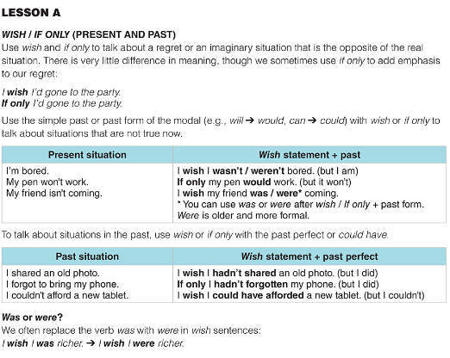
* I was bored -----→ I wish I had brought my phone OR If Only I had brought my phone.

Unit 4B – Conditionals
Future Real – If clause states a possible situation and uses the simple present. The result clause uses a future form (will)
Ex. If you change the settings, you will get automatic notifications.

Past Unreal – If clauses states an imagined condition that is not true at the moment and uses simple past. The result clause uses would / might / could + bare infinitive

Ex. If I knew my password, I would be able to read my emails.

Past Unreal – Used to talk about imaginary situations that did not happen in the past. If clause describes a situation that is often the opposite of what happened and uses past perfect (had + past participle), the result clause uses would have + past participle.

Ex. If they had known the call was fake, they wouldn’t have given their bank details

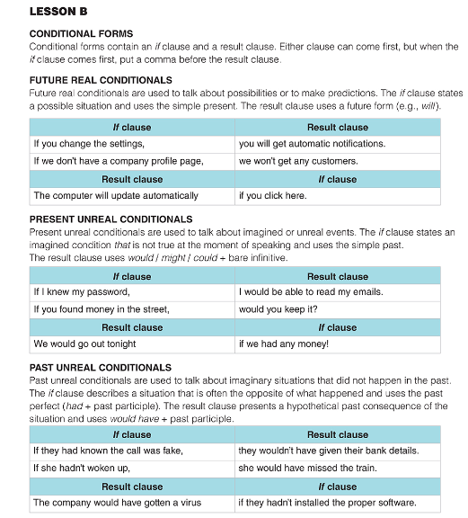
The rest of the exam: A reading comprehension part, answer questions based on the reading.
A writing comprehension part (two prompts: choose 1 and explain your opinion and thoughts.
A speaking part (I will ask you five questions, you answer them with fluency, correct grammar, strong vocabulary, engagement and relevance.

